


第四站：Letter to Poonam #English
Read the following letter between two pen pals and answer the questions on the next page.

Dear Poonam,
Greetings from China! Today was the third day of my family trip to Beijing when my parents took me to the Great Wall! Are you ready for an ancient adventure? Let’s dive in!

The 8 000-kilometre-long Great Wall was built around the seventh century in China. Imagine a strong wall, stretching for over 2 000 years, built to protect China from northern nomadic tribes. It was like a giant puzzle, with sections being built and joined together throughout history.

My father told me about the warring history when these walls were built. The states built them to protect themselves from invaders. However, it was Emperor Qin Shihuang, the first emperor of China, who started the construction of the Great Wall to keep the bad guys out. How would you design yours to keep the country safe? The further we climbed the steep steps, the more we understood that it wasn’t just a simple wall with huge bricks. There were entry and exit points of various scales to guard safety and watchtowers to send smoke signals in ancient times. It’s like having your secret code to communicate with allies!

For over 2 000 years, the Great Wall has stood tall to protect the Chinese land and its people from wars. I am proud of my ancestors and their wisdom. My mother promised to take me here again next October to see the sea of autumn leaves under my feet. Let’s have a look at the breathtaking scene in the photo I found online as attached.




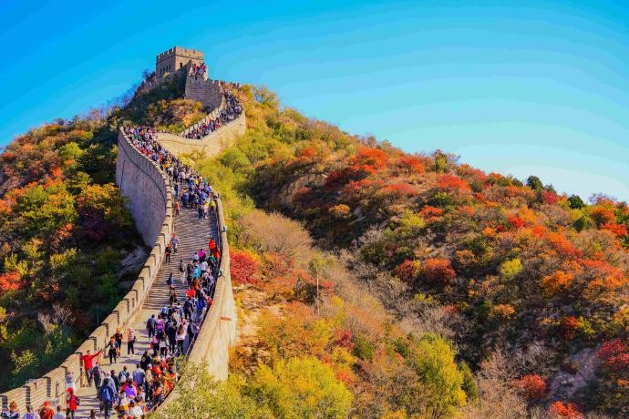
Fill in the blanks with the most suitable adjectives from the letter.
I hope you enjoy this written journey through time. Are there any historic sites of more than a thousand years old in India? Please share them with me in your next letter!
Your adventurous pen pal, Dennis

Attachment: Great wall in autumn.jpg
  - The (Line 3) temple stood tall, holding secrets from the past.
  - We were amazed by the (Line 22) sight of dolphins jumping above the crystal-clear water.
  - The moon landing in 1969 was a (Line 23) event that changed our understanding of space exploration.

Answer the following questions in complete sentences.
- Why the Great Wall was built?

- Why would Dennis say that “the Great Wall wasn’t just a simple wall with huge bricks”? (Line 14-15) Please tell one of the reasons.

- If you had a chance to visit the Great Wall, what would you do there? Why?

