課題三 ── 透視香港貧富差距
觀看團結香港基金「政策‧正察」頻道的影片「劏房戶熱夜焗住不歸家」，完成以下問題。
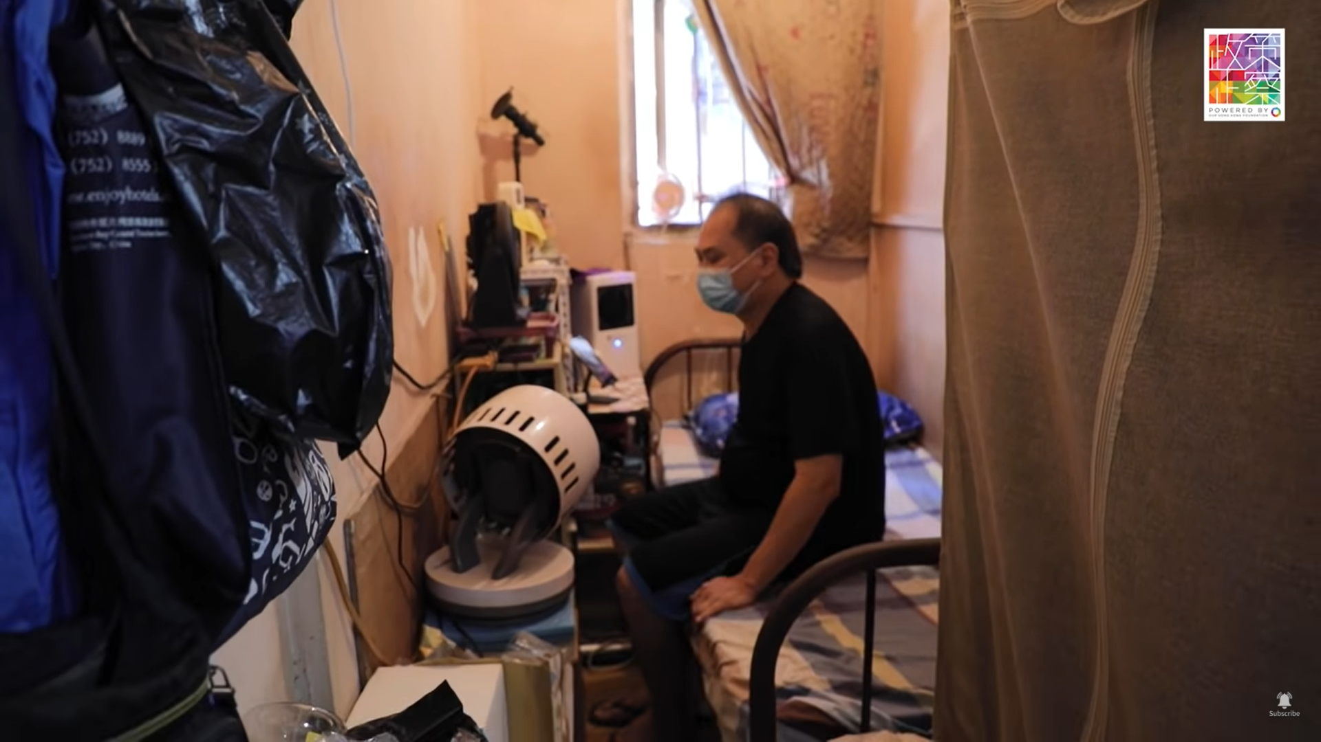
網址：https://www.youtube.com/watch?v=IkbP2PaRlBo
- 影片中的劏房有多大？
_________________________________________________________________________________
- 該劏房內有沒有獨立間隔如廚房、廁所？
_________________________________________________________________________________
- 該劏房的住戶面對甚麼居住問題？試說出兩個問題。
_________________________________________________________________________________
_________________________________________________________________________________
_________________________________________________________________________________
_________________________________________________________________________________
- 住戶怎麼面對那些居住問題？
_________________________________________________________________________________
_________________________________________________________________________________

